Project Title
Global DNA and Protein Sequence Alignment
Project Report submitted for the partial fulfilment of grade for the course

Data Structures and Algorithms -3 (25CS2103E)
in

A.Y. 2026-2027

Submitted by

Anushka Kulkarni – 2520030501
K. Akshaya – 2520030516
S. Hasini – 2520030287

Team Number: 11
Section: 4

Under the guidance of

Y. Yamini Devi


Assistant Professor , CSE Department>>
Hyderabad-500090, Telangana, India.

K L (Deemed to be) University
DEPARTMENT OF COMPUTER SCIENCE ENGINEERING



DECLARATION

The Mini Project Report entitled Global DNA and Protein Sequence Alignment is a record of Bonafide work of Anushka Kulkarni – 2520030501, K. Akshaya – 2520030516
S. Hasini – 2520030287 submitted in partial fulfillment for the award of B. Tech in Computer Science and Engineering/Computer Science and Information Technology/ Artifical Intelligence & data Science to the K L University. The results embodied in this report have not been copied from any other departments/University/Institute.

Anushka Kulkarni -2520030501
K. Akshaya – 2520030516
S. Hasini-2520030287

K L (Deemed to be) University
DEPARTMENT OF COMPUTER SCIENCE ENGINEERING / COMPUTER SCIENCE AND INFORMATION TECHNOLOGY
CERTIFICATE
This is to certify that the mini project based report entitled global dna and protein sequence alignment is a bonafide work done and submitted by Anushka Kulkarni – 2520030501, K. Akshaya – 2520030516
S. Hasini – 2520030287 in partial fulfillment of the requirements for the award of the degree of BACHELOR OF TECHNOLOGY in Department of Computer Science Engineering/ Computer Science and Information Technology/Artificial Intelligence & Data Science, K L (Deemed to be University), during the academic year 2026-2027.

Signature of the Supervisor

Signature of the HOD Signature of the External Examiner

ACKNOWLEDGEMENT

The success in this project would not have been possible but for the timely help and guidance rendered by many people. Our wish to express my sincere thanks to all those who has assisted us in one way or the other for the completion of my project.

Our greatest appreciation to my guide, Y. Yamini Devi, Assistant Professor, CSE department which cannot be expressed in words for her tremendous support, encouragement and guidance for this project.

We express our gratitude to Dr. P. Venkateshwar Rao (CSE), Head of the Department for Computer Science Engineering providing us with adequate facilities, ways and means by which we are able to complete this project-based Lab.

We thank all the members of teaching and non-teaching staff members, and also who have assisted me directly or indirectly for successful completion of this project. Finally, I sincerely thank my parents, friends and classmates for their kind help and cooperation during my work.

Anushka Kulkarni – 2520030501
M. Akshaya – 2520030516
S. Hasini – 2520030287

TABLE OF CONTENTS

S.No. | Contents | Page no.
1. | Abstract | 6
2. | Introduction | 8
3. | Literature survey | 9-11
4. | Problem Statement and Objectives | 12
5. | Hardware and Software requirements | 13
6. | Implementation | 14
7. | Results & Discussion | 15-17
8. | Conclusion & Future Scope | 18-20
9. | References | 21

1.ABSTRACT

The abstract of a project:
This DSA project focuses on developing a bioinformatics application for global sequence alignment using the Needleman–Wunsch algorithm. The main objective of the project is to compare DNA and protein sequences and determine their optimal alignment using dynamic programming. Sequence alignment is an important technique in computational biology that helps identify similarities and differences between biological sequences. The application allows users to enter two sequences and compare them using customizable scoring parameters, including match scores, mismatch penalties, and gap penalties. These parameters help evaluate different alignment possibilities and determine the most suitable alignment between the given sequences.
The application includes several key features that make sequence alignment easier to understand and analyze. It accepts DNA and protein sequences as input and uses a scoring matrix to calculate the optimal global alignment. The system calculates the alignment score based on matching characters, mismatches, and gaps. It also identifies matching and mismatching regions and displays the aligned sequences in a clear, structured format. The customizable scoring system allows users to experiment with different values and observe how they affect the final alignment. These features make the application useful for students who want to understand how biological sequence comparison works and explore the results of different alignment strategies.
The project demonstrates the practical implementation of important Data Structures and Algorithms concepts, particularly dynamic programming, matrix-based computation, and algorithmic problem-solving. The Needleman–Wunsch algorithm avoids repeatedly solving the same subproblems by storing intermediate results in a scoring matrix, helping determine the optimal alignment systematically. Through this project, students gain practical experience in algorithm design, sequence processing, and computational analysis. The application also demonstrates how DSA techniques can be applied to real-world problems in bioinformatics and biological research. Overall, the project combines theoretical knowledge with practical implementation and provides a foundation for understanding more advanced sequence-analysis methods used in genetics, molecular biology, and computational biology.
Team Name: 3 Bytes
Team Members:
Anushka Kulkarni – 2520030501
M. Akshaya – 2520030516
S. Hasini – 2520030287

- INTRODUCTION

Bioinformatics combines biology and computer science to analyze biological data, including DNA and protein sequences. Sequence alignment is an important technique in bioinformatics that helps identify similarities and differences between biological sequences. It is widely used in genetic research, protein analysis, and understanding relationships between organisms. Performing sequence alignment efficiently requires suitable algorithms that can compare sequences and determine the best possible alignment.
This project focuses on implementing the Needleman–Wunsch algorithm for global sequence alignment using dynamic programming. The algorithm compares two DNA or protein sequences by assigning scores for matches, penalties for mismatches, and penalties for gaps. It uses a scoring matrix to calculate the optimal alignment and determine the final alignment score. The application displays the aligned sequences in a structured format, allowing users to understand the similarities and differences between them.
The main objective of this project is to demonstrate the practical application of Data Structures and Algorithms (DSA) concepts in solving computational biology problems. It provides hands-on experience with dynamic programming, matrix operations, and algorithmic problem-solving. By combining theoretical concepts with practical implementation, the project helps users understand how efficient algorithms can be applied to biological sequence analysis and real-world research applications.

3.LITERATURE SURVEY

1. BLAST (Basic Local Alignment Search Tool)
BLAST is a widely used bioinformatics tool for comparing DNA and protein sequences. It identifies regions of similarity between sequences and helps researchers find related biological sequences. Our project is related to BLAST because both focus on comparing biological sequences to identify similarities.
Website: https://blast.ncbi.nlm.nih.gov/Blast.cgi
2. FASTA
FASTA is a sequence comparison tool used to identify similarities between DNA and protein sequences. It helps researchers search biological databases and find related sequences. Our project also compares biological sequences to identify matching regions and similarities.
Website: https://www.ebi.ac.uk/jdispatcher/sss/fasta
3. EMBOSS Needle
EMBOSS Needle is a bioinformatics tool that performs global sequence alignment using the Needleman–Wunsch algorithm. It aligns two sequences across their entire lengths and helps identify matches, mismatches, and gaps. Our project uses a similar approach to perform global DNA and protein sequence alignment.
Website: https://www.ebi.ac.uk/jdispatcher/psa/emboss_needle
4. EMBOSS Water
EMBOSS Water performs local sequence alignment using the Smith–Waterman algorithm. It identifies the most similar regions between two sequences rather than aligning their entire lengths. Studying this tool helps us understand the difference between global and local sequence alignment.
Website: https://www.ebi.ac.uk/jdispatcher/psa/emboss_water
5. NCBI GenBank
GenBank is a public database containing DNA sequences and their associated biological information. Researchers use it to access and study genetic information from different organisms. Our project can use DNA sequences obtained from public databases to demonstrate global sequence alignment.
Website: https://www.ncbi.nlm.nih.gov/genbank/
6. UniProt
UniProt is a major resource for protein sequences and functional information. It helps researchers access protein data for biological analysis and comparison. Our project can use protein sequences from UniProt to perform global protein sequence alignment.
Website: https://www.uniprot.org/
7. Needleman–Wunsch Algorithm
The Needleman–Wunsch algorithm is a dynamic programming algorithm used for global sequence alignment. It compares two sequences by considering matches, mismatches, and gaps to find an optimal alignment. This algorithm forms the main foundation of our project for aligning complete DNA and protein sequences.
Reference: Needleman, S. B., and Wunsch, C. D. (1970), “A General Method Applicable to the Search for Similarities in the Amino Acid Sequence of Two Proteins.”
DOI: https://doi.org/10.1016/0022-2836(70)90057-4
8. Smith–Waterman Algorithm
The Smith–Waterman algorithm uses dynamic programming to find the best local alignment between two biological sequences. It focuses on the most similar regions of the sequences. Studying this algorithm helps us understand alternative methods of sequence comparison and the importance of selecting an appropriate alignment approach.
Reference: Smith, T. F., and Waterman, M. S. (1981), “Identification of Common Molecular Subsequences.”
DOI: https://doi.org/10.1016/0022-2836(81)90087-5
9. BLOSUM Substitution Matrices
BLOSUM matrices are used in protein sequence alignment to assign scores to amino acid matches and substitutions. They help account for biological similarities between different amino acids. Our project can use a suitable substitution matrix to improve the scoring of protein sequence alignments.
Reference: Henikoff, S., and Henikoff, J. G. (1992), “Amino Acid Substitution Matrices from Protein Blocks.”
DOI: https://doi.org/10.1073/pnas.89.22.10915
10. Pairwise Sequence Alignment
Pairwise sequence alignment compares two DNA or protein sequences to identify similarities and differences. It uses scoring systems for matches, mismatches, and gaps to determine an alignment. Our project focuses on global pairwise alignment, which compares sequences across their entire lengths and helps researchers study biological relationships.
Reference: Global sequence alignment concepts and dynamic programming methods used in bioinformatics.

- REFERENCES:
1.Needleman, S. B., and Wunsch, C. D. (1970). “A General Method Applicable to the Search for Similarities in the Amino Acid Sequence of Two Proteins.” Journal of Molecular Biology, 48(3), 443–453. https://doi.org/10.1016/0022-2836(70)90057-4
2.Smith, T. F., and Waterman, M. S. (1981). “Identification of Common Molecular Subsequences.” Journal of Molecular Biology, 147(1), 195–197.
https://doi.org/10.1016/0022-2836(81)90087-5
3.Altschul, S. F., et al. (1990). “Basic Local Alignment Search Tool.” Journal of Molecular Biology, 215(3), 403–410.
https://doi.org/10.1016/S0022-2836(05)80360-2
4.Henikoff, S., and Henikoff, J. G. (1992). “Amino Acid Substitution Matrices from Protein Blocks.” Proceedings of the National Academy of Sciences, 89(22), 10915–10919. https://doi.org/10.1073/pnas.89.22.10915
5.National Center for Biotechnology Information (NCBI). GenBank: DNA Sequence Database. https://www.ncbi.nlm.nih.gov/genbank/
6.UniProt Consortium. UniProt: The Universal Protein Knowledgebase. https://www.uniprot.org/
7.European Bioinformatics Institute (EMBL-EBI). EMBOSS Needle: Global Sequence Alignment. https://www.ebi.ac.uk/jdispatcher/psa/emboss_needle
8.European Bioinformatics Institute (EMBL-EBI). EMBOSS Water: Local Sequence Alignment. https://www.ebi.ac.uk/jdispatcher/psa/emboss_water
9.European Bioinformatics Institute (EMBL-EBI). FASTA Sequence Similarity Search. https://www.ebi.ac.uk/jdispatcher/sss/fasta
10.National Center for Biotechnology Information (NCBI). BLAST: Basic Local Alignment Search Tool. https://blast.ncbi.nlm.nih.gov/Blast.cgi

4.Problem Statement and Objectives

Problem Statement:

Comparing DNA and protein sequences manually is difficult and time-consuming. An efficient system is needed to compare two biological sequences, identify similarities and differences, and find their optimal global alignment. This project uses the Needleman–Wunsch algorithm and dynamic programming to align sequences and calculate the alignment score.

Objectives:

- To implement the Needleman–Wunsch algorithm using dynamic programming.
- To align two DNA or protein sequences globally.
- To identify matching characters, mismatches, and gaps.
- To calculate and display the alignment score.
- To present the aligned sequences clearly through a user-friendly interface

- HARDWARE AND SOFTWARE REQUIREMENTS

Hardware Requirements:
- Processor: Intel Core i3 or above
- RAM: Minimum 4 GB
- Hard Disk: Minimum 500 GB
- System: Desktop or Laptop
- Input Devices: Keyboard and Mouse

Software Requirements:
- Operating System: Windows 10/11 or Linux or macOS
- Programming Language: Python
- IDE: Visual Studio Code or PyCharm
- Algorithm: Needleman–Wunsch Algorithm
- Technique: Dynamic Programming
- Application: DNA and Protein Sequence Alignment System

- IMPLEMENTATION

Module 1: Sequence Input and Validation
This module allows users to enter two DNA or protein sequences. It validates the input, checks for empty sequences and invalid characters, and prepares the sequences for alignment.
Module 2: Needleman–Wunsch Algorithm
This module implements the Needleman–Wunsch algorithm using dynamic programming. It initializes the scoring matrix and calculates scores based on matches, mismatches, and gap penalties to determine the optimal global alignment.
Module 3: Matrix Visualization and Traceback
This module displays the scoring matrix and allows users to visualize how cells are filled step by step. It highlights the current cell and traces backward through the matrix to reconstruct the optimal alignment.
Module 4: Results Analysis and History
This module displays the aligned sequences, final alignment score, number of matches, mismatches, and gaps. It also allows users to save previous results and download alignment reports for future reference.

- RESULTS & DISCUSSION
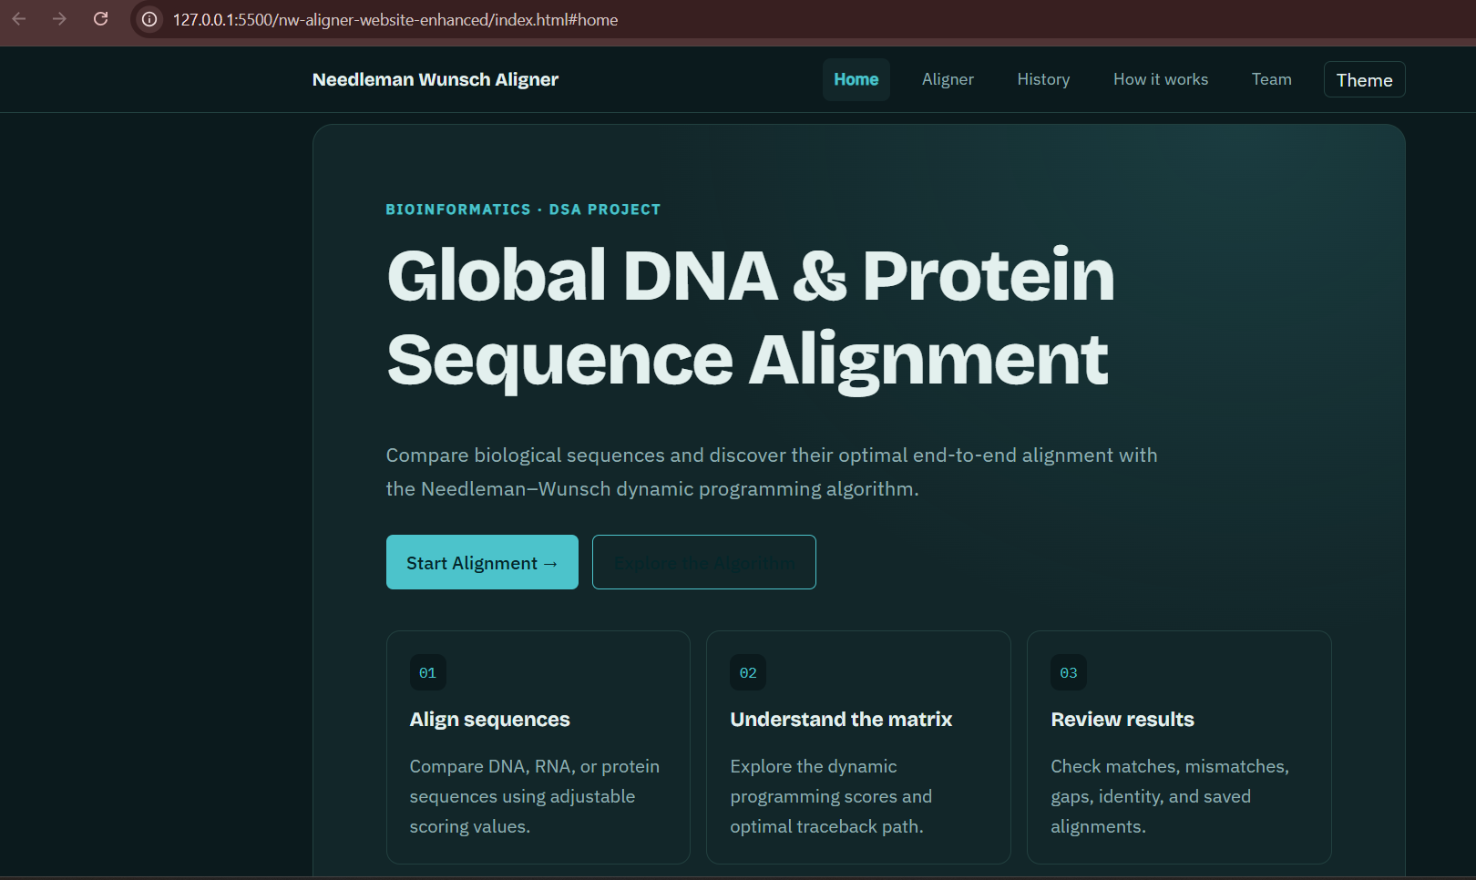
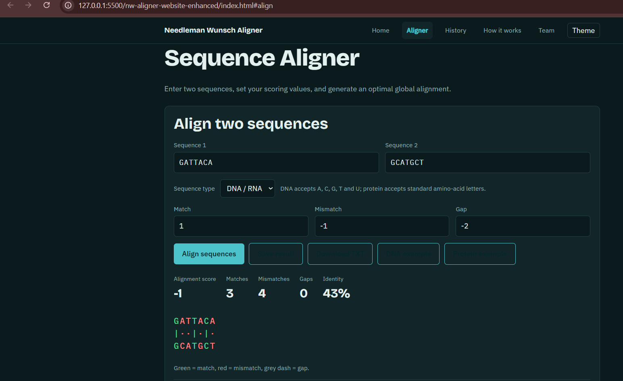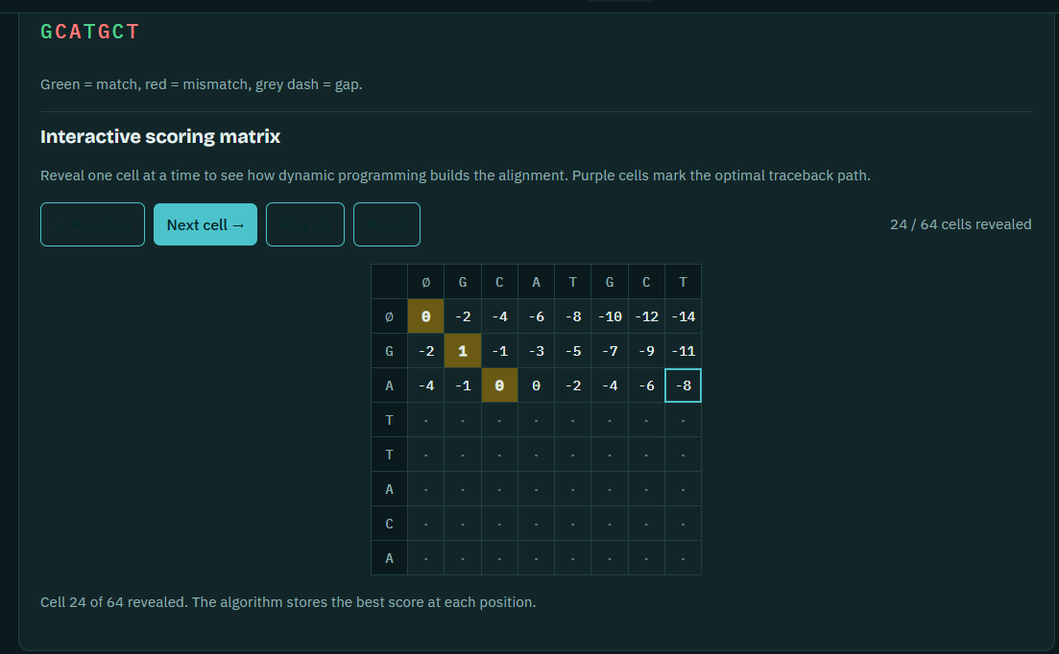
This page explains how the Needleman–Wunsch algorithm fills a scoring matrix, compares scores, and traces backward to find the optimal alignment of two sequences.
It also shows the recurrence formula and the algorithm’s time and space complexity, both O(mn), where m and n are the sequence lengths.

- CONCLUSION & FUTURE SCOPE

Conclusion:

The project Global DNA and Protein Sequence Alignment Using the Needleman–Wunsch Algorithm focuses on comparing DNA and protein sequences using dynamic programming. The algorithm identifies similarities and differences between two sequences by considering matches, mismatches, and gaps. It uses a scoring matrix to calculate the optimal global alignment and determine the alignment score.
This project demonstrates the practical application of Data Structures and Algorithms (DSA), particularly dynamic programming, matrix operations, and traceback techniques. It helps users understand how biological sequences can be compared systematically and how algorithmic techniques can solve problems in bioinformatics.
The project provides a foundation for understanding sequence alignment and its importance in genetic research, protein analysis, and computational biology.

Future Scope
1. Short-Term Improvements
- Improve the user interface to make the application simple and user-friendly.
- Add more DNA and protein sequence examples for testing.
- Highlight matching characters, mismatches, and gaps using different colors.
- Display the scoring matrix to help users understand the alignment process.
2. Medium-Term Improvements
- Add options to upload and download sequences in FASTA format.
- Improve performance when processing longer sequences.
- Provide graphical visualization of sequence alignment.
- Allow users to customize match scores, mismatch penalties, and gap penalties.
3. Long-Term Improvements
- Integrate advanced algorithms such as the Smith–Waterman algorithm for local sequence alignment.
- Connect the application to biological sequence databases such as GenBank and UniProt.
- Incorporate suitable substitution matrices, such as BLOSUM, for protein alignment.
- Extend the application into a more advanced bioinformatics tool for students and researchers.

9.REFERENCES

- Needleman, S. B., and Wunsch, C. D. (1970). “A General Method Applicable to the Search for Similarities in the Amino Acid Sequence of Two Proteins.” Journal of Molecular Biology, 48(3), 443–453. https://doi.org/10.1016/0022-2836(70)90057-4
- Smith, T. F., and Waterman, M. S. (1981). “Identification of Common Molecular Subsequences.” Journal of Molecular Biology, 147(1), 195–197.
https://doi.org/10.1016/0022-2836(81)90087-5
- Biopython Documentation. “Pairwise Sequence Alignment.” Available at:
https://biopython.org/docs/latest/Tutorial/chapter_pairwise.html
- National Center for Biotechnology Information (NCBI). “BLAST: Basic Local Alignment Search Tool.” Available at: https://blast.ncbi.nlm.nih.gov/Blast.cgi
- National Center for Biotechnology Information (NCBI). “GenBank: DNA Sequence Database.” Available at: https://www.ncbi.nlm.nih.gov/genbank/
- UniProt Consortium. “UniProt: The Universal Protein Knowledgebase.” Available at:
https://www.uniprot.org/
- European Bioinformatics Institute (EMBL-EBI). “EMBOSS Needle: Global Sequence Alignment.” Available at: https://www.ebi.ac.uk/jdispatcher/psa/emboss_needle
- European Bioinformatics Institute (EMBL-EBI). “EMBOSS Water: Local Sequence Alignment.” Available at: https://www.ebi.ac.uk/jdispatcher/psa/emboss_water
- Altschul, S. F., et al. (1990). “Basic Local Alignment Search Tool.” Journal of Molecular Biology, 215(3), 403–410. https://doi.org/10.1016/S0022-2836(05)80360-2
- Henikoff, S., and Henikoff, J. G. (1992). “Amino Acid Substitution Matrices from Protein Blocks.” Proceedings of the National Academy of Sciences, 89(22), 10915–10919.
https://doi.org/10.1073/pnas.89.22.10915

